APPENDIX

E

SAMPLE EXCEL FORMAT

**Table E.1 Excel File of Students by Subject**

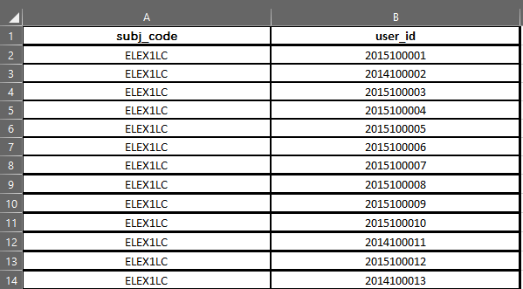

**Table E.2 Excel File of Students by Cluster**

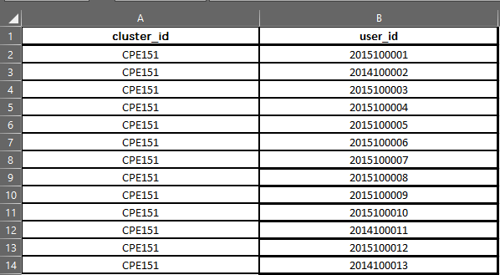

**Table E.3 Excel File for Faculty by Subject**

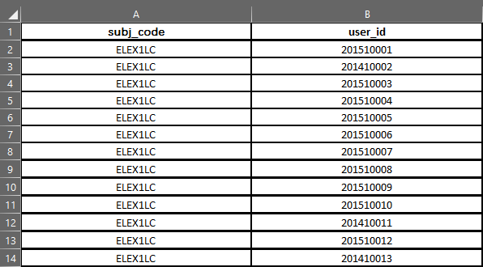

**Table E.4 Excel File of Faculty per Cluster**

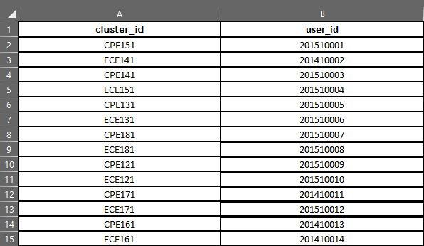

**Table E.5 Excel File of Student Information**

